**Follow the below mentioned steps to add an extension in Chrome:**

1. Save the zip file from your mail to your system.
2. Extract the folder “w3cValidatorExtension” contained in the zip file to your desktop or any other location.
3. Now open google chrome browser.
4. Open url ***chrome://extensions/*** in a new tab. You will see this window:

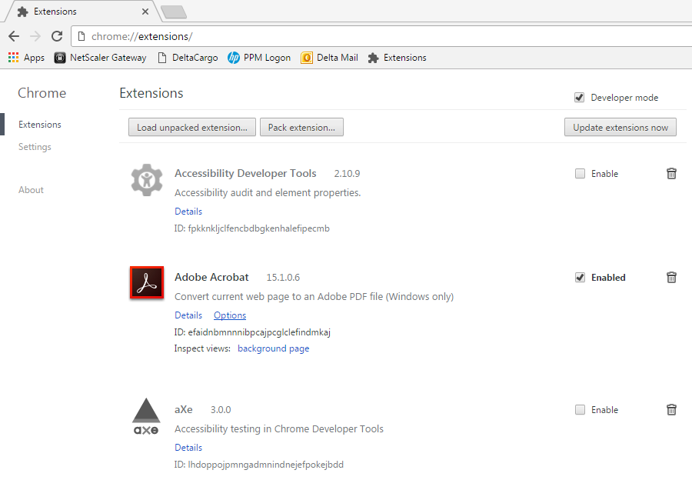

1. Make sure that the “**Developer mode**” checkbox should be checked.

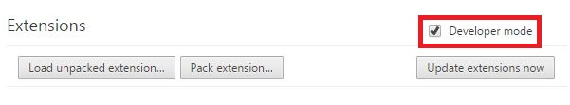

1. Now drag the extracted folder “**w3cValidatorExtension**” and drop it in this window:

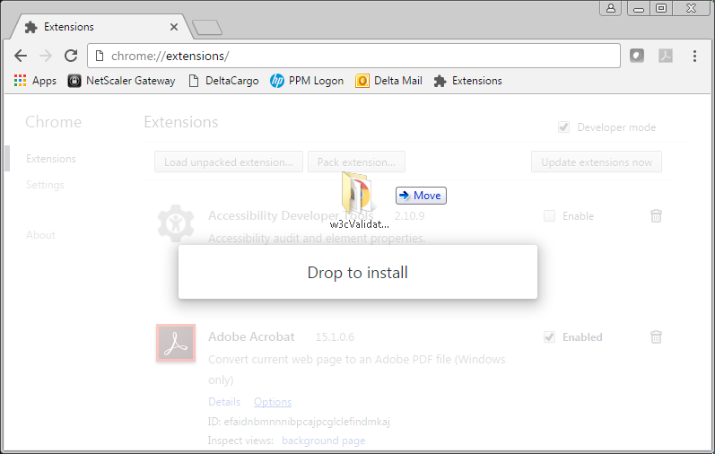

1. The extension will automatically add after this to your extensions and extension icon would be created in your chrome toolbar as shown below: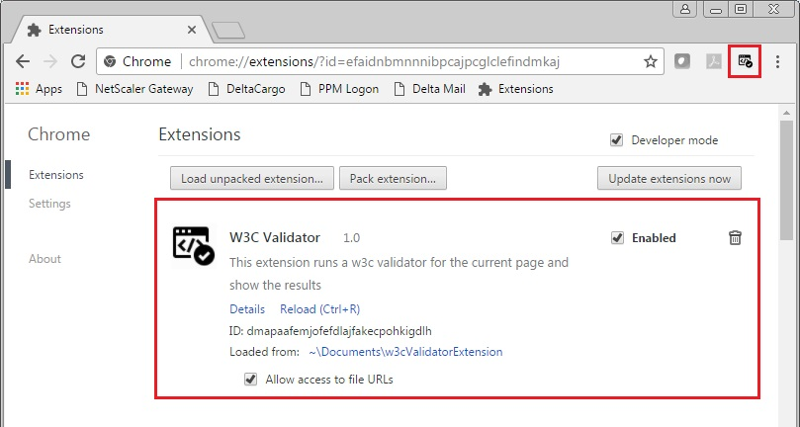
2. Now open any url in a new tab say [www.google.com](http://www.google.com)
3. Click on W3C Validator icon from chrome toolbar. You will see w3c validation results within seconds without doing any addition efforts. You can also open the results in new tab by clicking the link “**Open results in new tab**”.

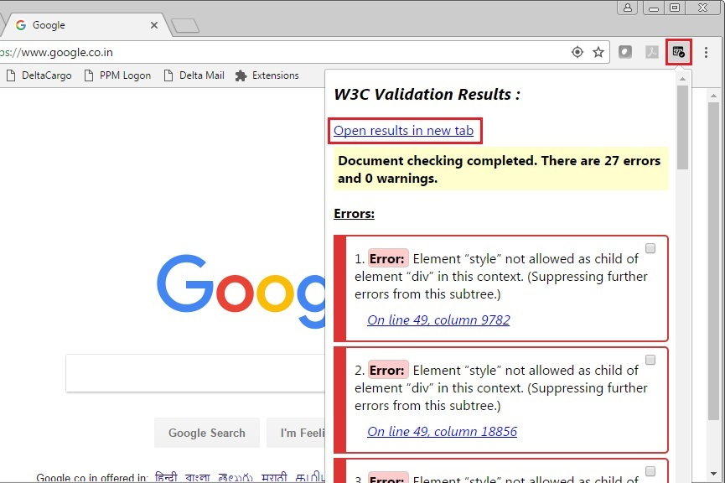

1. All the validation errors and warnings that will come up also have a checkbox associated with it. You can check it if you have already solved that error, this will make a UI change in error presentation as shown below:

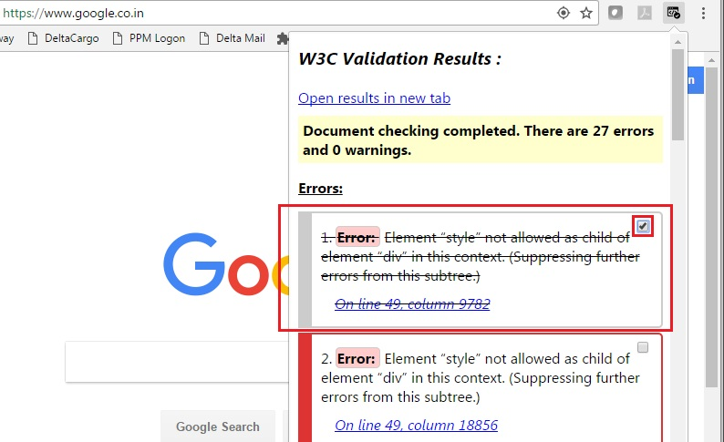

1. You are now ready to make full use of this google chrome extension.

**Thanks & Regards,**

**Yatin Aggarwal (477157)**

CDBINT